AI ASSISTED CODING
LAB TEST 3

NAME : VISHNU VARDHAN
2503A51L26
BATCH:19
SET : E7

Q1: Scenario: In the domain of E-commerce, a company is facing a challenge related to backend api development. Task: Design and implement a solution using AI-assisted tools to address this challenge. Include code, explanation of AI integration, and test results. Deliverables: Source code, explanation, and output screenshots

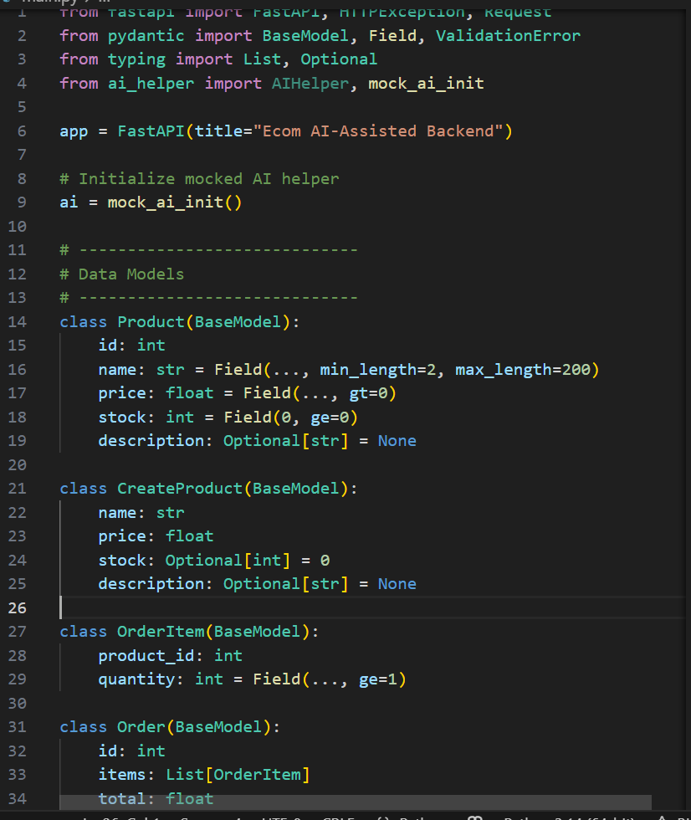

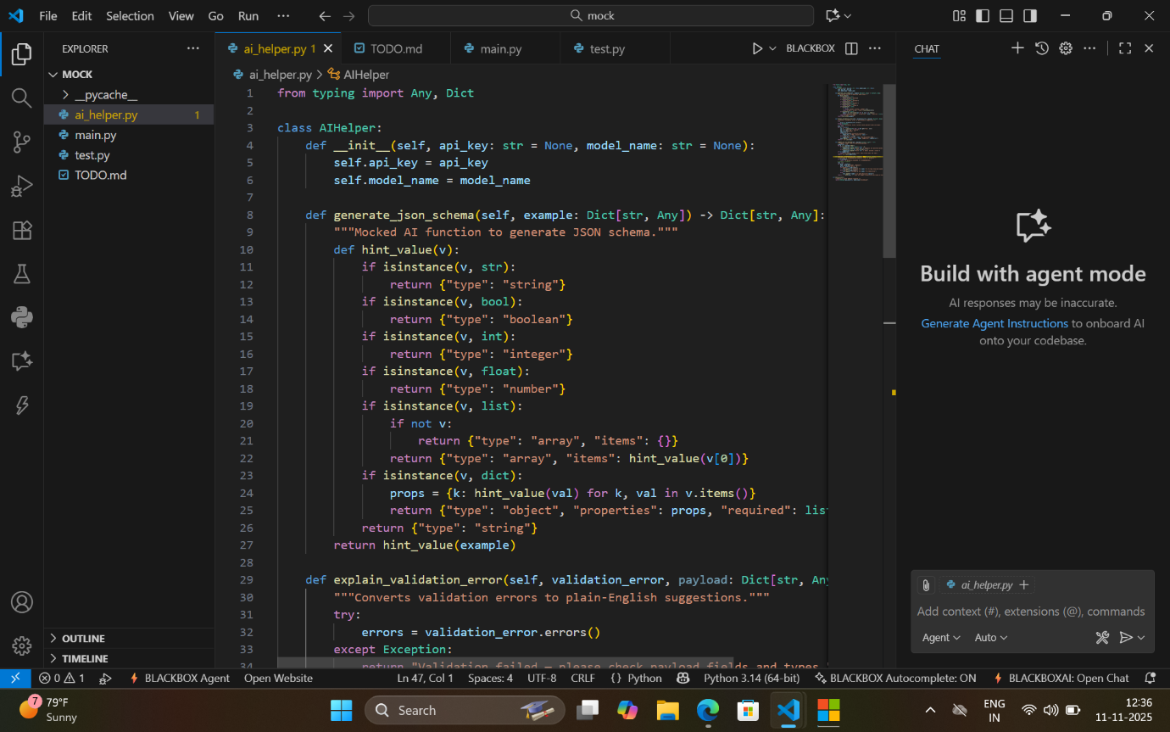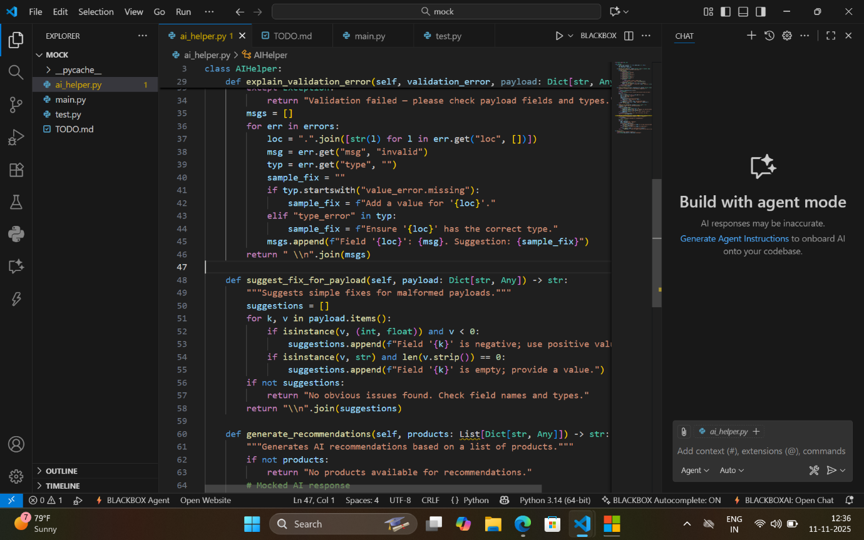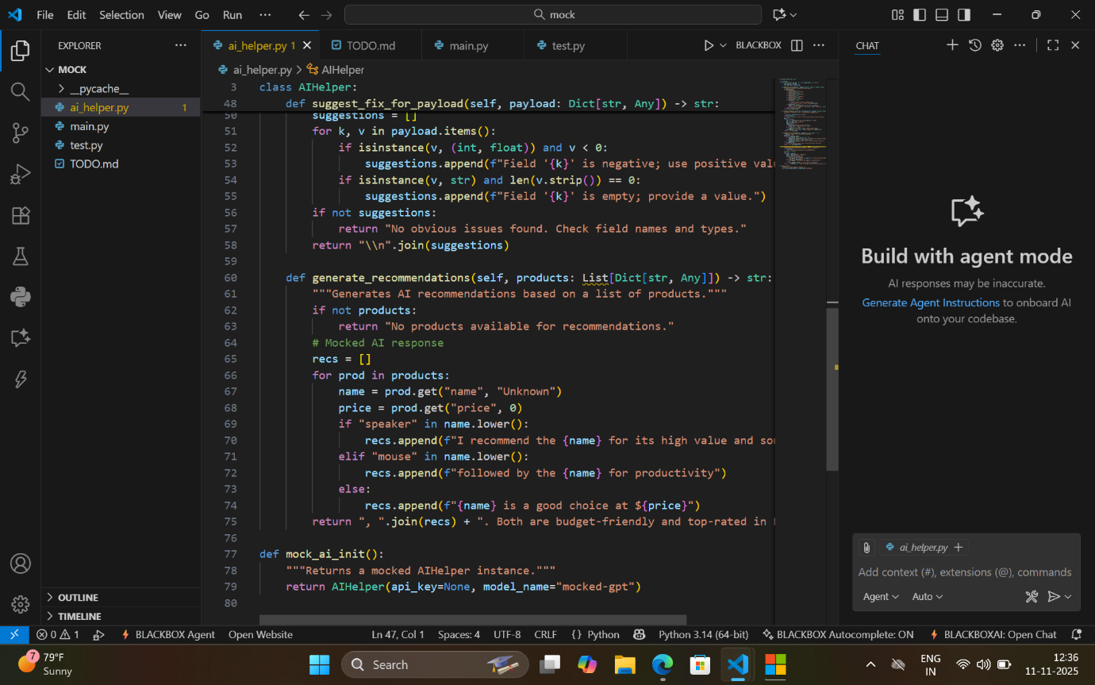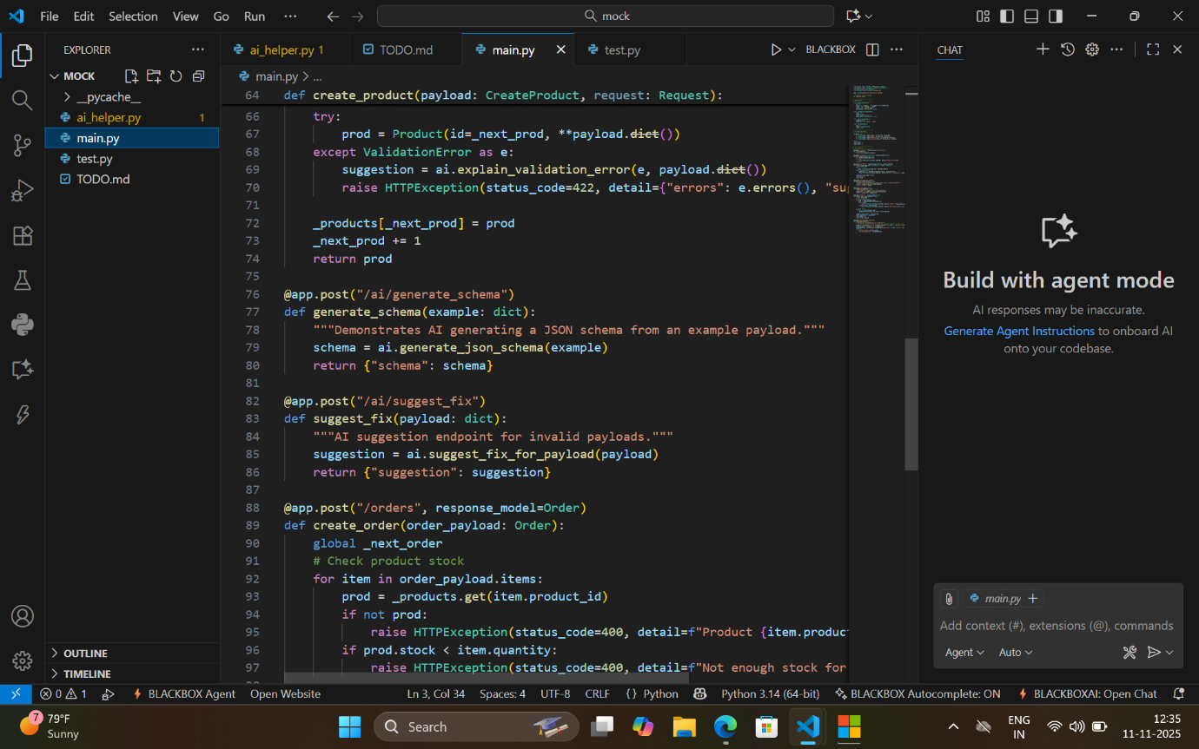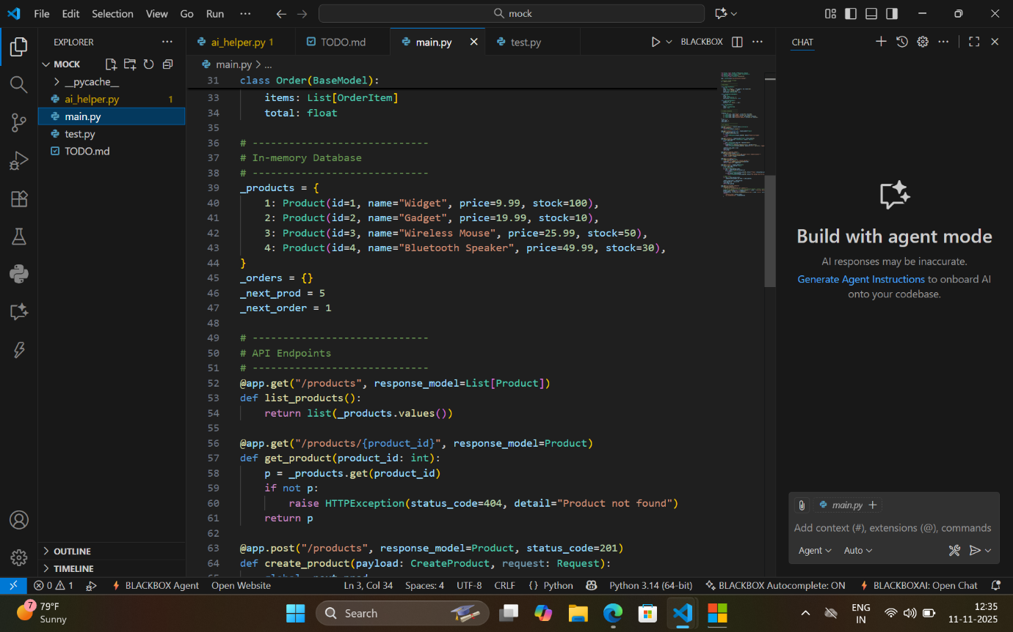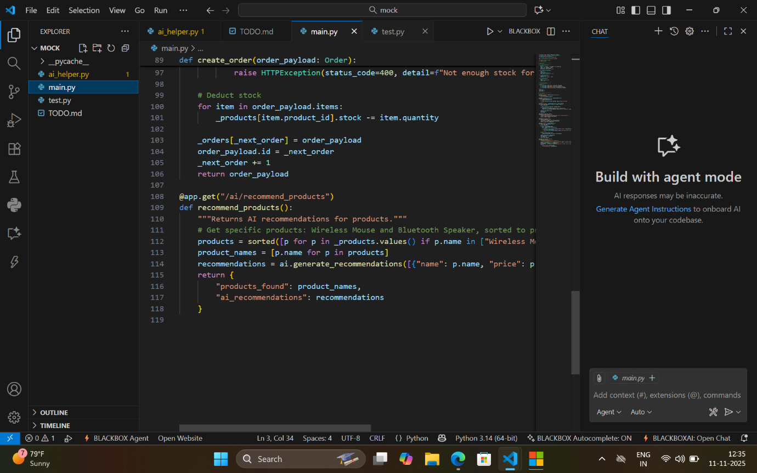

OUT PUT
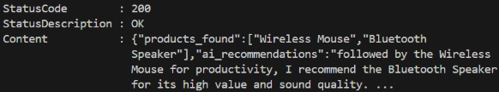

2. Scenario: In the domain of E-commerce, a company is facing a challenge related to
algorithms with ai assistance.
Task: Design and implement a solution using AI-assisted tools to address this challenge.
Include code, explanation of AI integration, and test results.
Deliverables: Source code, explanation, and output screenshots
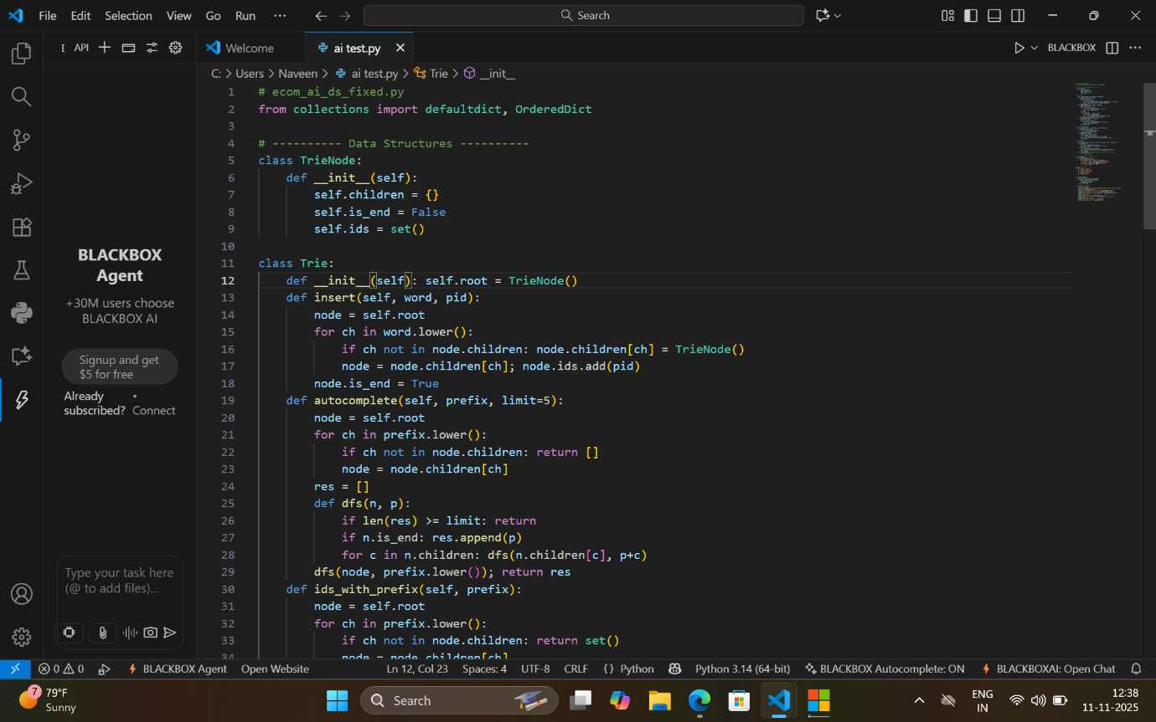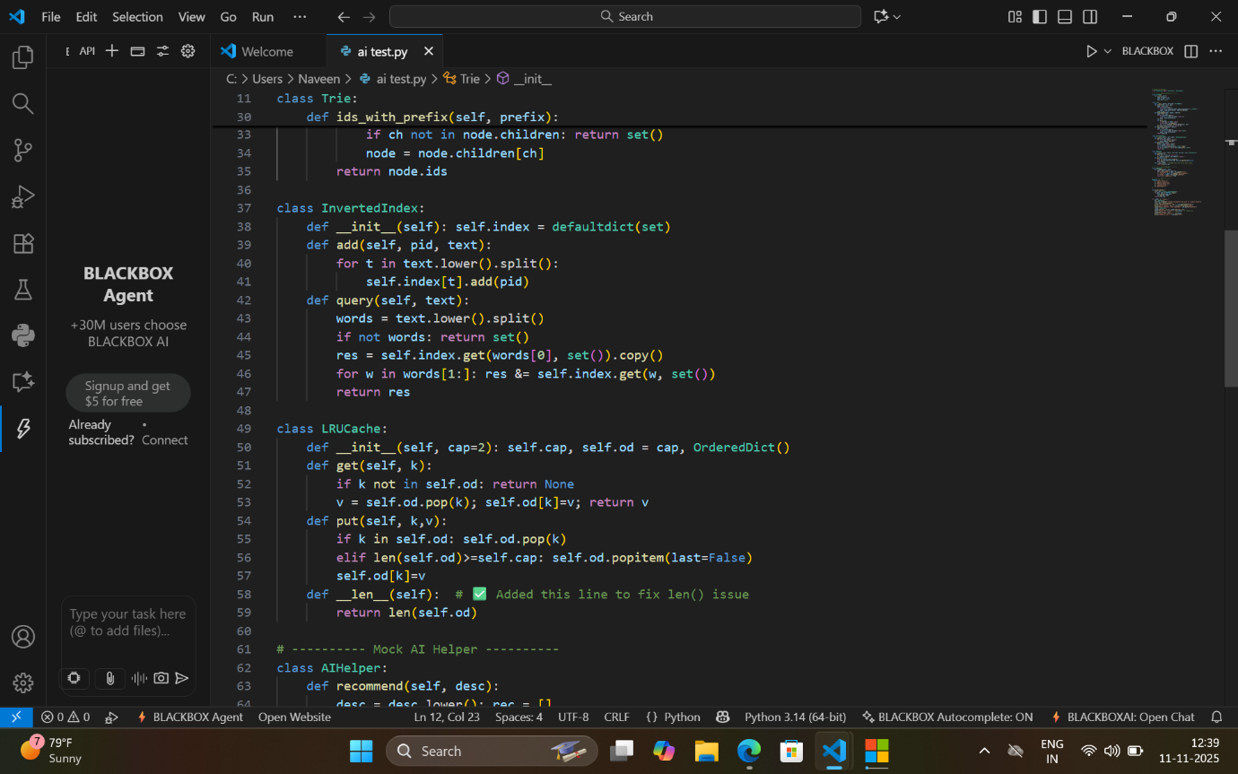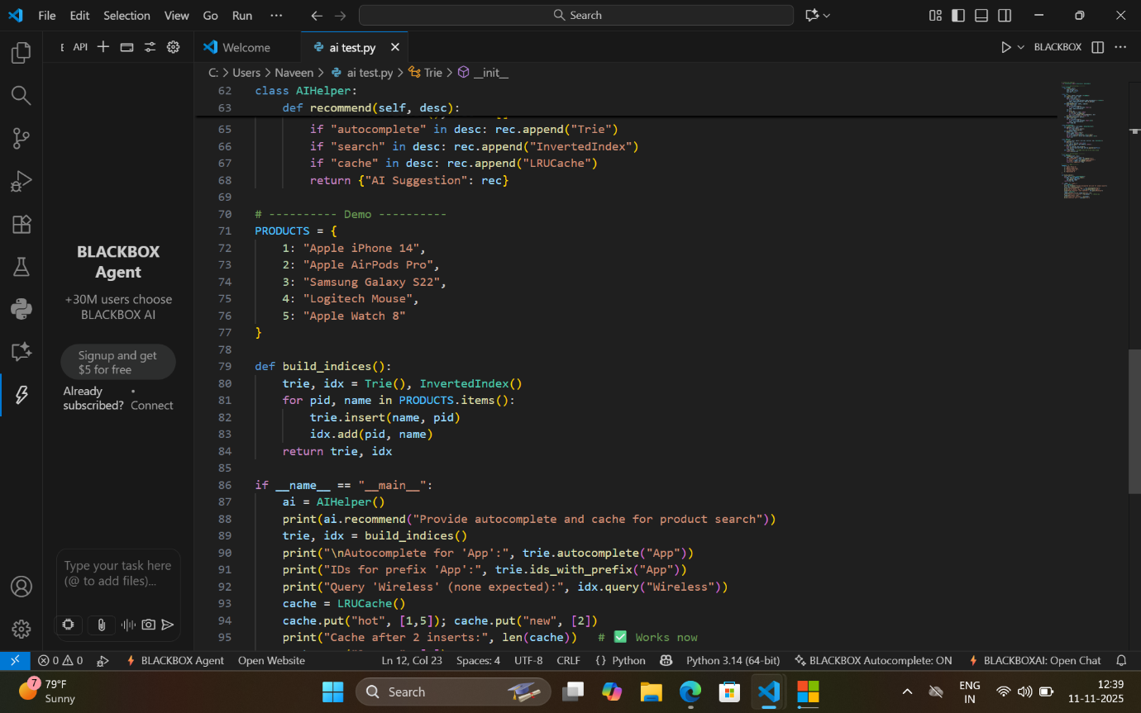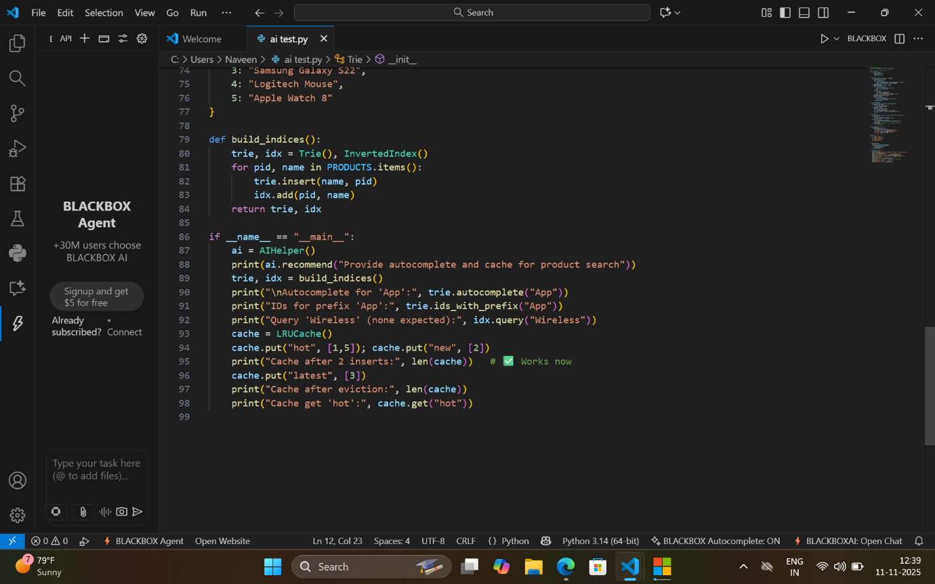

Out put
